NEW CHILDREN UNDER 16 PATIENT QUESTIONNAIRE

DATE: ……………………………….. FEMALE/MALE

SURNAME: ……………………………………………… FIRST NAMES: ……………………………………………………………………………….

ANY PREVIOUS SURNAME …………………………………………………………………………………………………………………………………

ADDRESS: ……………………………………………………………………………………………………………………………………………………………

…………………………………………………………………………………………………………………………………………………………………………...

TELEPHONE: HOME ……………………………………………………………. MOBILE …………………………………………………………….

EMAIL: ……………………………………………………………………………………………..

WHO DO THESE DETAILS BELONG TO? (e.g mum, dad etc) ………………………………………………………………………………

CAN WE LEAVE A MESSAGE ON: HOME/MOBILE TEXT MESSAGE: YES/NO

PERSON WITH PARENTAL RESPONSIBILITY: NAME: ……………………………………………………………………………………

RELATIONSHIP : ………………………………………………………………….. CONTACT NUMBER: ………………………………………

WHO ELSE LIVES IN THIS HOUSEHOLD: MUM DAD STEP PARENT PARENT’S PARTNER

GRANDPARENTS BROTHERS AND SISTERS HOW MANY? FOSTER CARER GUARDIANS

OTHERS – PLEASE STATE …………………………………………………………………….

NEXT OF KIN: - NAME: ……………………………………………… PHONE NUMBER: ……………………………………………………

RELATIONSHIP TO YOU: (e.g daughter) ……………………………………………………………………………………………………………

DOES YOUR CHILD CARE FOR ANYONE? ………………………………………………………………..

DETAILS OF THE PERSON THIS CHILD CARES FOR: …………………………………………………………………………………………

ADDRESS/CONTACT NO’S: …………………………………………………………………………………………………………………………………

MAIN LANGUAGE SPOKEN: ………………………………………………………. INTERPRETER NEEDED: YES/NO

PERSONAL MEDICAL HISTORY

HAS YOUR CHILD HAD ANY SERIOUS ILLNESS OR OPERATIONS? YES NO

YES NO

IF YES, WHAT WAS THIS AND WHEN? ……………………………………………………………………………………………………………..

DOES YOUR CHILD HAVE A DISABILITY OR CHRONIC CONDITION? YES NO
YES NO
YES NO
IF YES, PLEASE SPECIFY …………………………………………………………………..

MEDICATION:

IS YOUR CHILD ON ANY REGULAR MEDICATION? YES NO
YES NO
YES NO
ALLERGIES:

DO YOU HAVE ANY ALLERGIES TO ANY MEDICATIONS: YES/NO

IF YES, PLEASE LIST: ……………………………………………………………………………………………………………………………………………

FAMILY HISTORY

HEART DISEASE BEFORE AGE 60 YES/NO FAMILY MEMBER: ……………………………………………

HEART DISEASE AFTER AGE 60 YES/NO FAMILY MEMBER: ……………………………………………

STROKE YES/NO FAMILY MEMBER: ……………………………………………

HIGH BLOOD PRESSURE YES/NO FAMILY MEMBER: ……………………………………………

DIABETES YES/NO FAMILY MEMBER: ……………………………………………

ASTHMA YES/NO FAMILY MEMBER: ……………………………………………

COLON CANCER YES/NO FAMILY MEMBER: ……………………………………………

PROSTATE CANCER YES/NO FAMILY MEMBER: ……………………………………………

BREAST CANCER YES/NO FAMILY MEMBER: ……………………………………………

GLAUCOMA YES/NO FAMILY MEMBER: ……………………………………………

MEDICAL SUMMARY
PLEASE LIST ANY SERIOUS ILLNESSES, HOSPITAL ADMISSIONS OR OPERATIONS THAT YOU HAVE HAD.

DATE | PROBLEM

WHICH SCHOOL OR NURSERY DOES YOUR CHILD ATTEND? ………………………………………………………………………………

DOES YOUR CHILD HAVE CONTACT WITH ANY OF THE FOLLOWING?
YES NO
- A HOSPITAL SPECIALIST
- A HEALTH VISITOR
YES NO
- A SOCIAL WORKER
YES NO
- ANY OTHER HEALTH PROFESSIONALS?
YES NO

HAS YOUR CHILD EVER BEEN UNDER A CHILD PROTECTION PLAN? YES NO
YES NO
YES NO

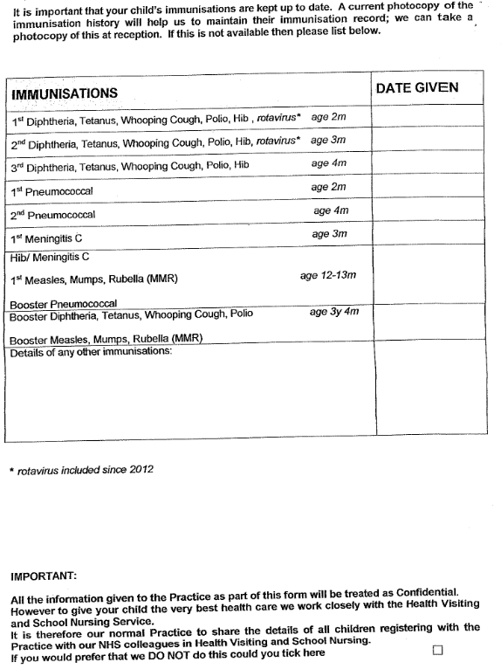
10. ETHNICITY

WHAT IS YOUR ETHNIC GROUP?

WHITE
BRITISH

IRISH

ANY OTHER WHITE BACKGROUND PLEASE STATE ……………………………………………………………………………

MIXED
WHITE AND BLACK CARRIBEAN

WHITE AND BLACK AFRICAN

WHITE AND ASIAN

ANY OTHER MIXED BACKGROUND. PLEASE STATE ……………………………………………………………………………

ASIAN OR ASIAN BRITISH

INDIAN

PAKISTANI

BANGLADESHI

ANY OTHER MIXED BACKGROUND, PLEASE STATE …………………………………………………………………………………………

BLACK OR BLACK BRITISH

CARRIBEAN

AFRICIAN

ANY OTHER BLACK BACKGROUND, PLEASE STATE …………………………………………………………………………………………

CHINESE OR OTHER ETHNIC GROUP

CHINESE

ANY OTHER PLEASE STATE ……………………………………………………………………………………………………………………………..

NOT STATED

FEMALE CHILDREN ONLY

FGM – In line with current guidance we now need to ask our female patients the following

Are you from a country where FGM (cutting/female circumcision occurs)? Please see list:
YES/NO

Have you ever been cut?
YES/NO

If yes are you under 18:
YES/NO. If you are under18 we will arrange for a Doctor to discuss the next steps.

Do you have female children?
YES/NO

If yes, is FGM (cutting/female circumcision) something you are considering or have had to your female children?
YES/NO

If yes we must advise you that is now an illegal practice we would need to report this to the police.

Would you like to talk to anyone about FGM?
YES/NO

